Chapter 16, Solution 12.

Determine i(t) in the circuit of Fig. 16.35 by means of the Laplace transform.

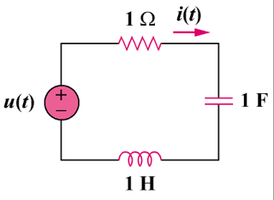
u(t)V

Figure 16.35
For Prob. 16.12.

Solution

Consider the s-domain form of the circuit which is shown below.

1/s

1
+

1/s

s

I(s)

u(t) A

